**WITH NOISE AND WITHOUT FILTER FUZZY**

**Image set:**

|  |
| --- |
| **Image 1:-0.1 % Noise** |

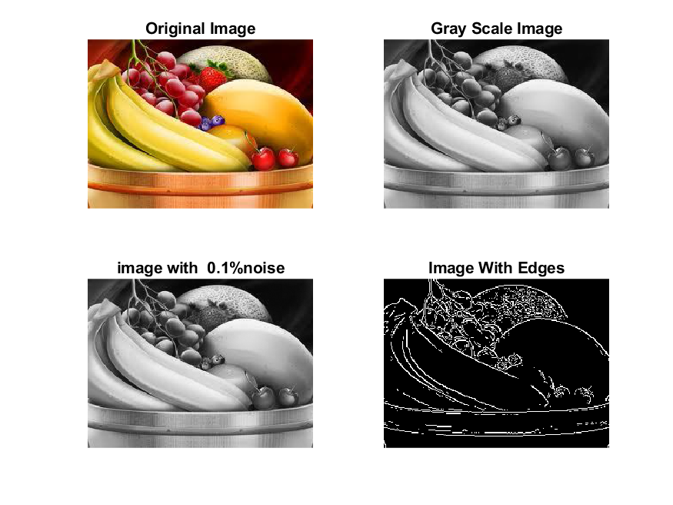

**Image 2:-10 % Noise**

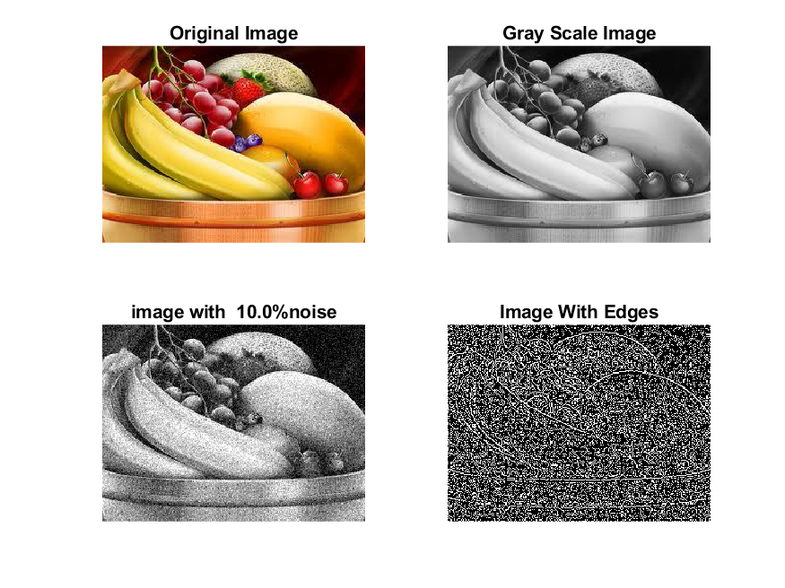

**Image 3:-20 % Noise**

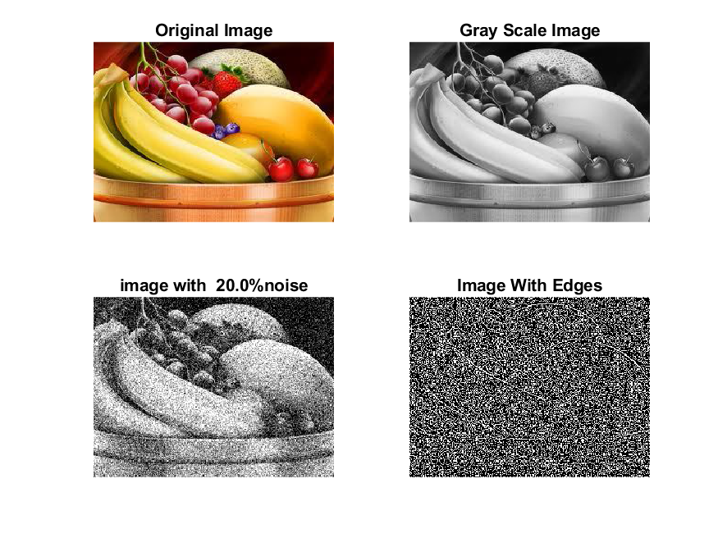

**Image 4:-30 % Noise**

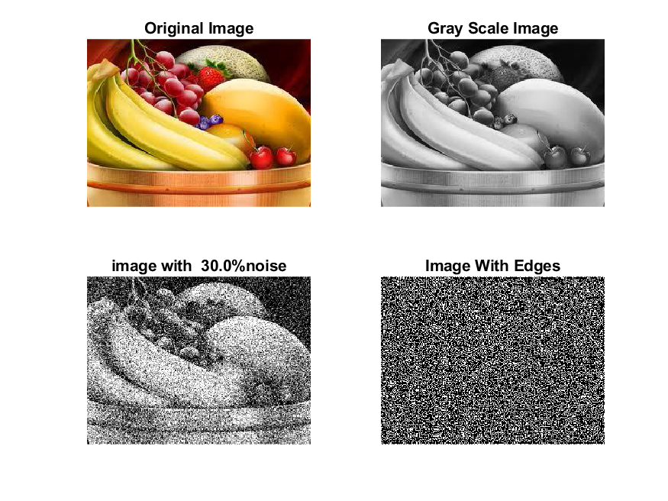

|  |
| --- |
| **Image 5:-40 % Noise** |

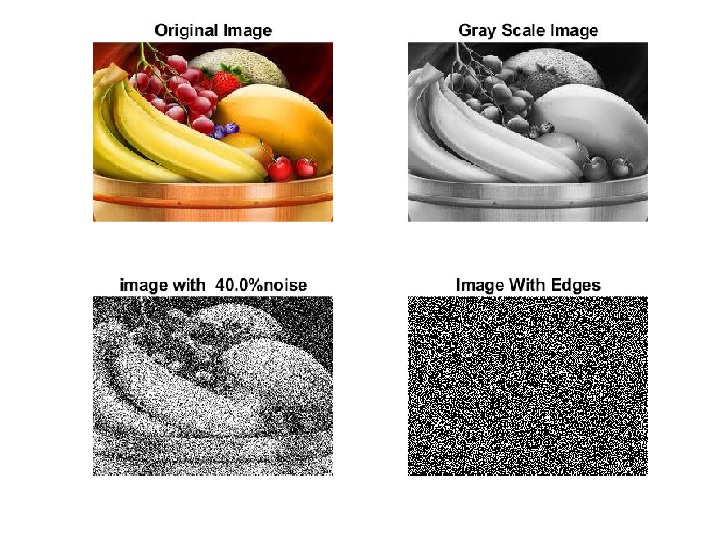

**Image 6:-50 % Noise**

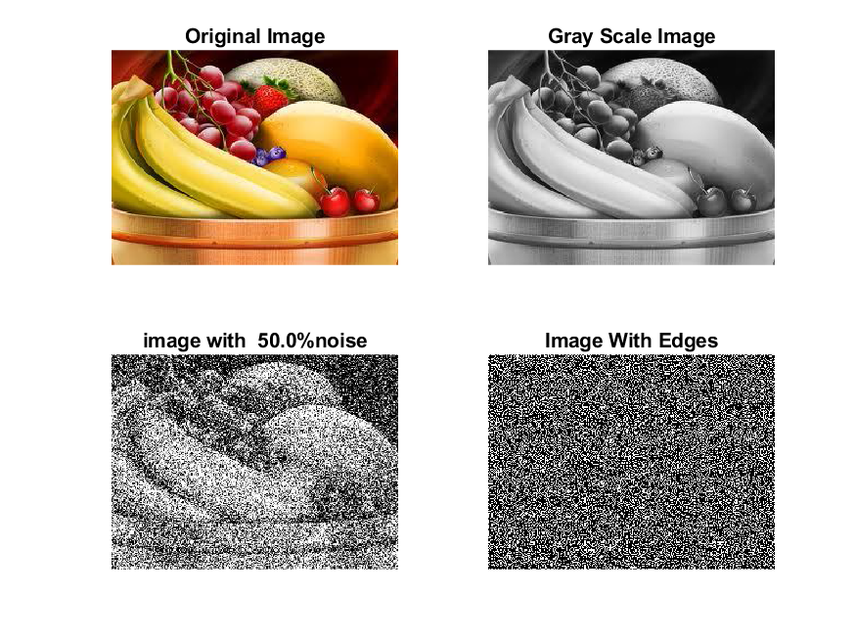

**Image 7:-60 % Noise**

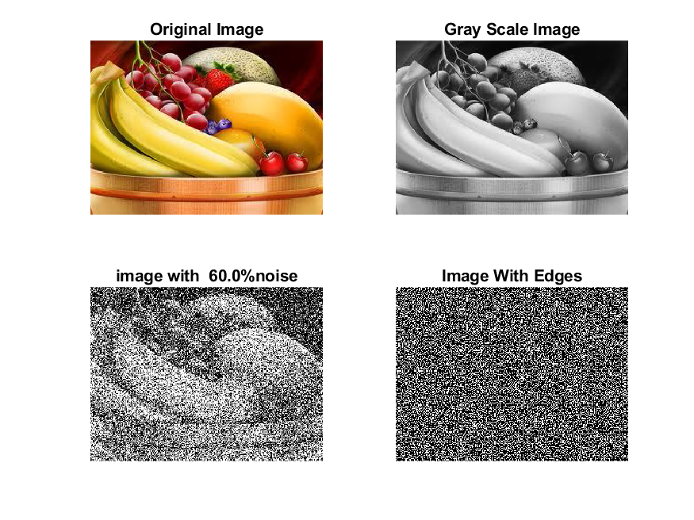

**Image 8:-70 % Noise**

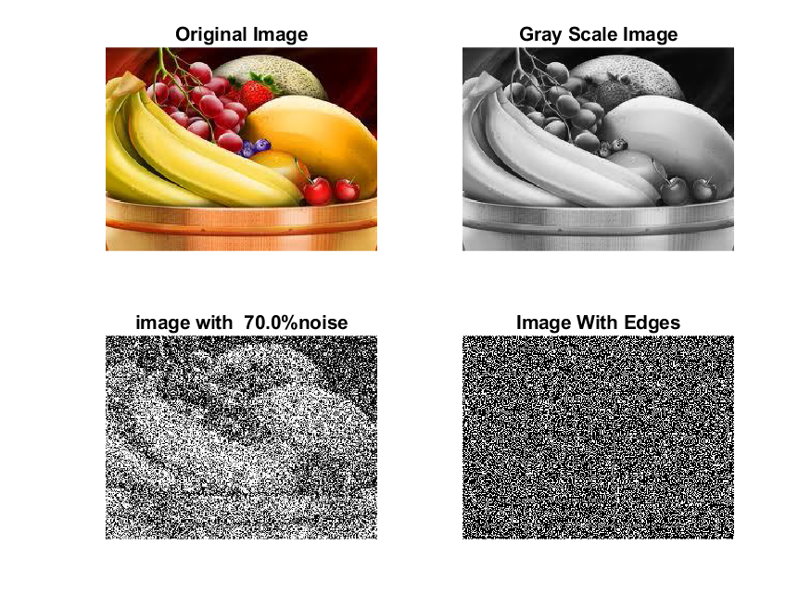

**Image 9:-80 % Noise**

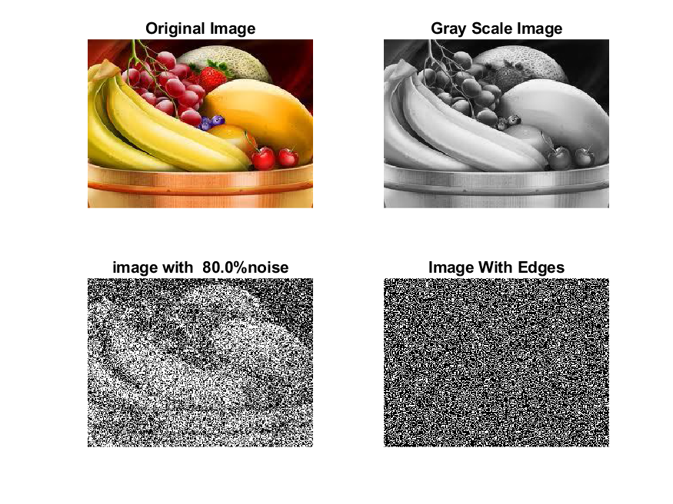

**DATA FILES**

**Image 1:-Noise0.1**

Original image ideal values:

IM1 image entropy:4.327962e-01

IM1 image mean:0.088903

Ground truth image entropy:0.815119

Ground truth image mean:0.252438

entropy between imt and im1 :0.765039

MSE between imt and im1 :0.281833

Average Difference between imt and im1 :0.163535

Maximum Difference between imt and im1 :1.000000

True Positive values:1495.000000

False Positive values: 2972.000000

True Negative values:34590.000000

False Negative values:11189.000000

Accuracy value: 0.718167

F Measure values:0.174334

Peak Signal-to Noise Ration value: 5.500076

Signal-to Noise Ration value: -4.532403

percentage of pixels that were correctly detected (Pco): 0.117865

The percentage of pixels that were not detected (Pnd):0.882135

the percentage of false alarm: (Pfa):0.234311

Euclidean Distance Value :10.861092

**Image 2:-Noise10**

Original image ideal values:

IM1 image entropy:8.758029e-01

IM1 image mean:0.295566

Ground truth image entropy:0.815119

Ground truth image mean:0.252438

entropy between imt and im1 :0.678495

MSE between imt and im1 :0.401684

Average Difference between imt and im1 :-0.043128

Maximum Difference between imt and im1 :1.000000

True Positive values:3676.000000

False Positive values: 11175.000000

True Negative values:26387.000000

False Negative values:9008.000000

Accuracy value: 0.598316

F Measure values:0.267006

Peak Signal-to Noise Ration value: 3.961158

Signal-to Noise Ration value: 0.684995

percentage of pixels that were correctly detected (Pco): 0.247525

The percentage of pixels that were not detected (Pnd):0.606558

the percentage of false alarm: (Pfa):0.752475

Euclidean Distance Value :23.790217

**Image 3:-Noise20**

Original image ideal values:

IM1 image entropy:9.200635e-01

IM1 image mean:0.335111

Ground truth image entropy:0.815119

Ground truth image mean:0.252438

entropy between imt and im1 :0.657713

MSE between imt and im1 :0.422680

Average Difference between imt and im1 :-0.082673

Maximum Difference between imt and im1 :1.000000

True Positive values:4142.000000

False Positive values: 12696.000000

True Negative values:24866.000000

False Negative values:8542.000000

Accuracy value: 0.577320

F Measure values:0.280604

Peak Signal-to Noise Ration value: 3.739879

Signal-to Noise Ration value: 1.230343

percentage of pixels that were correctly detected (Pco): 0.245991

The percentage of pixels that were not detected (Pnd):0.507305

the percentage of false alarm: (Pfa):0.754009

Euclidean Distance Value :23.634039

**Image 4:-Noise30**

Original image ideal values:

IM1 image entropy:9.202011e-01

IM1 image mean:0.335251

Ground truth image entropy:0.815119

Ground truth image mean:0.252438

entropy between imt and im1 :0.654745

MSE between imt and im1 :0.420232

Average Difference between imt and im1 :-0.082813

Maximum Difference between imt and im1 :1.000000

True Positive values:4207.000000

False Positive values: 12638.000000

True Negative values:24924.000000

False Negative values:8477.000000

Accuracy value: 0.579768

F Measure values:0.284940

Peak Signal-to Noise Ration value: 3.765104

Signal-to Noise Ration value: 1.232148

percentage of pixels that were correctly detected (Pco): 0.249748

The percentage of pixels that were not detected (Pnd):0.503235

the percentage of false alarm: (Pfa):0.750252

Euclidean Distance Value :24.008903

**Image 5:-Noise40**

Original image ideal values:

IM1 image entropy:9.235823e-01

IM1 image mean:0.338714

Ground truth image entropy:0.815119

Ground truth image mean:0.252438

entropy between imt and im1 :0.653278

MSE between imt and im1 :0.422422

Average Difference between imt and im1 :-0.086276

Maximum Difference between imt and im1 :1.000000

True Positive values:4239.000000

False Positive values: 12780.000000

True Negative values:24782.000000

False Negative values:8445.000000

Accuracy value: 0.577578

F Measure values:0.285426

Peak Signal-to Noise Ration value: 3.742538

Signal-to Noise Ration value: 1.276778

percentage of pixels that were correctly detected (Pco): 0.249075

The percentage of pixels that were not detected (Pnd):0.496210

the percentage of false alarm: (Pfa):0.750925

Euclidean Distance Value :23.941510

**Image 6:-Noise50**

Original image ideal values:

IM1 image entropy:9.242531e-01

IM1 image mean:0.339410

Ground truth image entropy:0.815119

Ground truth image mean:0.252438

entropy between imt and im1 :0.651760

MSE between imt and im1 :0.421805

Average Difference between imt and im1 :-0.086972

Maximum Difference between imt and im1 :1.000000

True Positive values:4272.000000

False Positive values: 12782.000000

True Negative values:24780.000000

False Negative values:8412.000000

Accuracy value: 0.578195

F Measure values:0.287309

Peak Signal-to Noise Ration value: 3.748886

Signal-to Noise Ration value: 1.285700

percentage of pixels that were correctly detected (Pco): 0.250498

The percentage of pixels that were not detected (Pnd):0.493257

the percentage of false alarm: (Pfa):0.749502

Euclidean Distance Value :24.083565

**Image 7:-Noise60**

Original image ideal values:

IM1 image entropy:9.270363e-01

IM1 image mean:0.342336

Ground truth image entropy:0.815119

Ground truth image mean:0.252438

entropy between imt and im1 :0.649360

MSE between imt and im1 :0.422661

Average Difference between imt and im1 :-0.089898

Maximum Difference between imt and im1 :1.000000

True Positive values:4324.000000

False Positive values: 12877.000000

True Negative values:24685.000000

False Negative values:8360.000000

Accuracy value: 0.577339

F Measure values:0.289376

Peak Signal-to Noise Ration value: 3.740083

Signal-to Noise Ration value: 1.322975

percentage of pixels that were correctly detected (Pco): 0.251381

The percentage of pixels that were not detected (Pnd):0.486018

the percentage of false alarm: (Pfa):0.748619

Euclidean Distance Value :24.171447

**Image 8:-Noise70**

Original image ideal values:

IM1 image entropy:9.263974e-01

IM1 image mean:0.341659

Ground truth image entropy:0.815119

Ground truth image mean:0.252438

entropy between imt and im1 :0.648387

MSE between imt and im1 :0.421148

Average Difference between imt and im1 :-0.089221

Maximum Difference between imt and im1 :1.000000

True Positive values:4345.000000

False Positive values: 12822.000000

True Negative values:24740.000000

False Negative values:8339.000000

Accuracy value: 0.578852

F Measure values:0.291113

Peak Signal-to Noise Ration value: 3.755653

Signal-to Noise Ration value: 1.314382

percentage of pixels that were correctly detected (Pco): 0.253102

The percentage of pixels that were not detected (Pnd):0.485758

the percentage of false alarm: (Pfa):0.746898

Euclidean Distance Value :24.343262

**Image 9:-Noise80**

Original image ideal values:

IM1 image entropy:9.330490e-01

IM1 image mean:0.348864

Ground truth image entropy:0.815119

Ground truth image mean:0.252438

entropy between imt and im1 :0.649730

MSE between imt and im1 :0.429507

Average Difference between imt and im1 :-0.096426

Maximum Difference between imt and im1 :1.000000

True Positive values:4316.000000

False Positive values: 13213.000000

True Negative values:24349.000000

False Negative values:8368.000000

Accuracy value: 0.570493

F Measure values:0.285705

Peak Signal-to Noise Ration value: 3.670299

Signal-to Noise Ration value: 1.405009

percentage of pixels that were correctly detected (Pco): 0.246221

The percentage of pixels that were not detected (Pnd):0.477380

the percentage of false alarm: (Pfa):0.753779

Euclidean Distance Value :23.656094